We modeled several fire effects metrics using TLS scan data to explore how reliably TLS can be used to predict fire effects.
Avg. Canopy Scorch:
- N=17
- Variables in model: h_ground_cnt, hr0_10_l1_cnt, hr100_1000_l1_mean
- R^2 = 0.606, rmse = 2.5
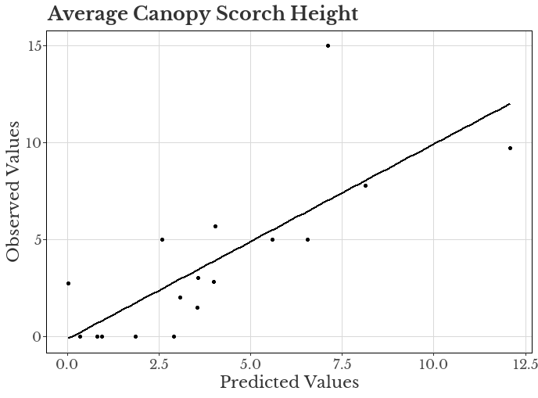
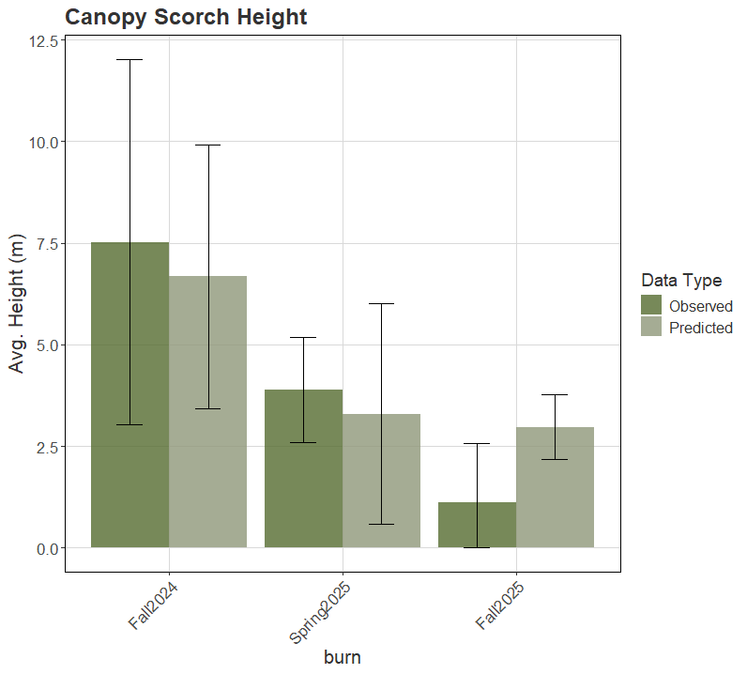

Substrate Burn Severity
N = 60
h_ground_cnt + h_ng_vari + h_l2_cnt
r^2 = .83, rmse = 0.26
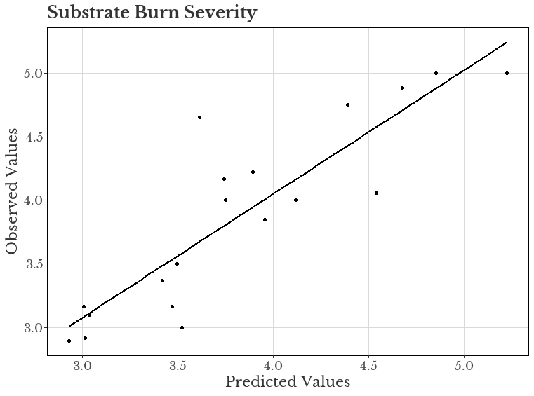
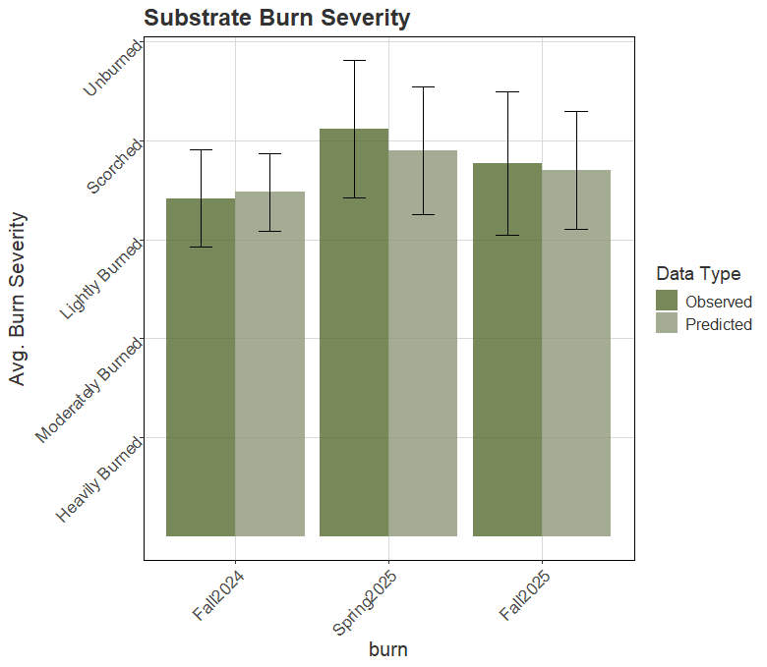

Fuel Consumption:
- N = 34
- Variables: s_l3_prop_ku + hr0_10_l1_tgi +hr100_1000_l1_tgi
- R^2 = 0.71, rmse = 1.9
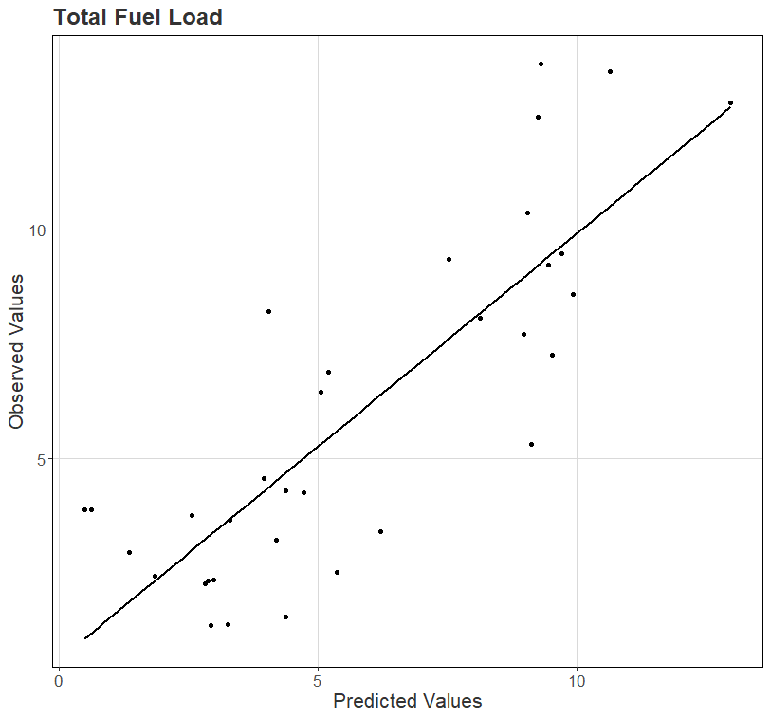

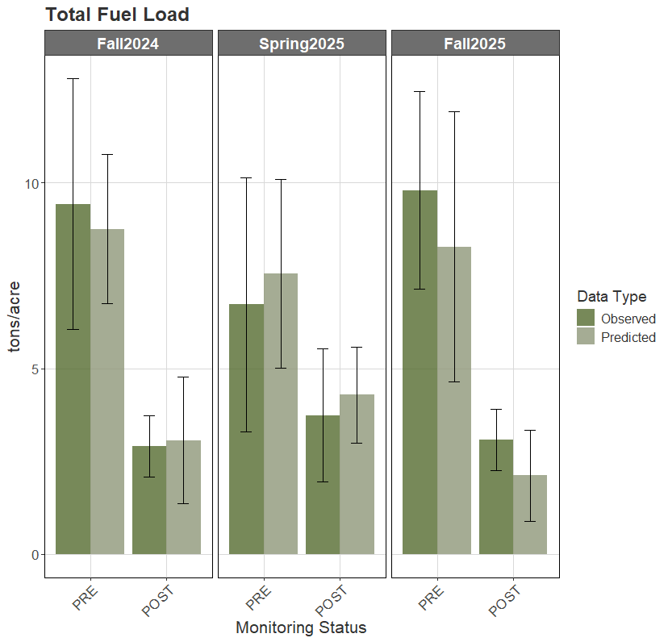
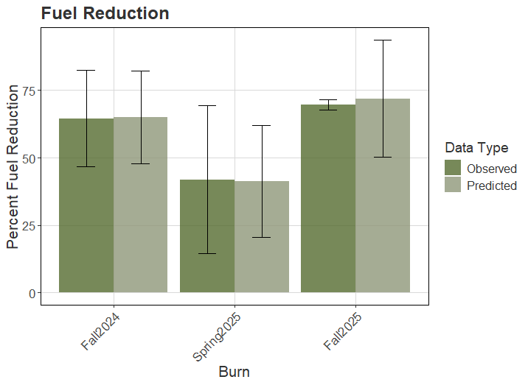

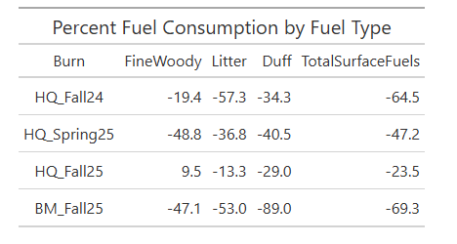

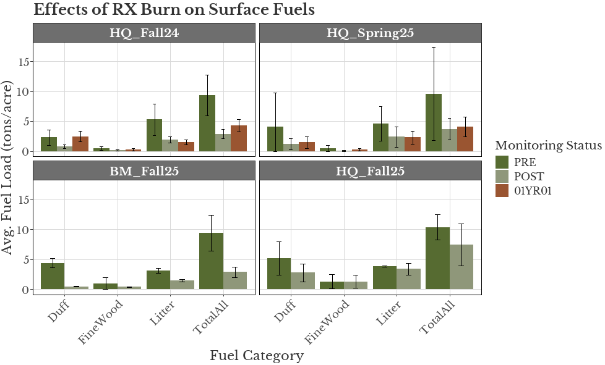
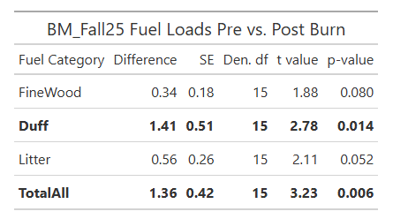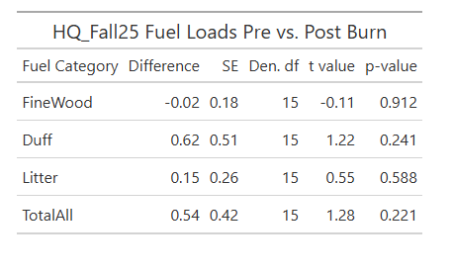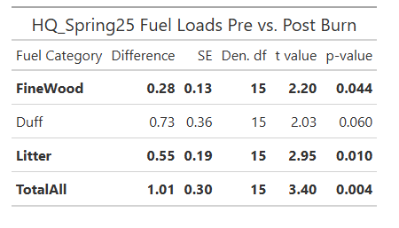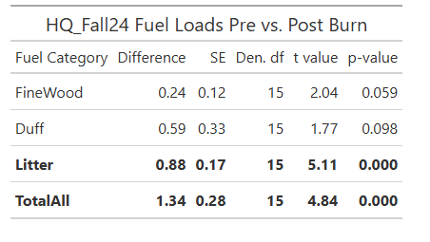
Linear mixed effects model on log-transformed fuels data; “bray” method with 999 permutations (vegan package adonis2)
Fall24: p = 0.001, Spring25: p = 0.028, HQ fall25: p = 0.25, BM Fall25: p = 0.25
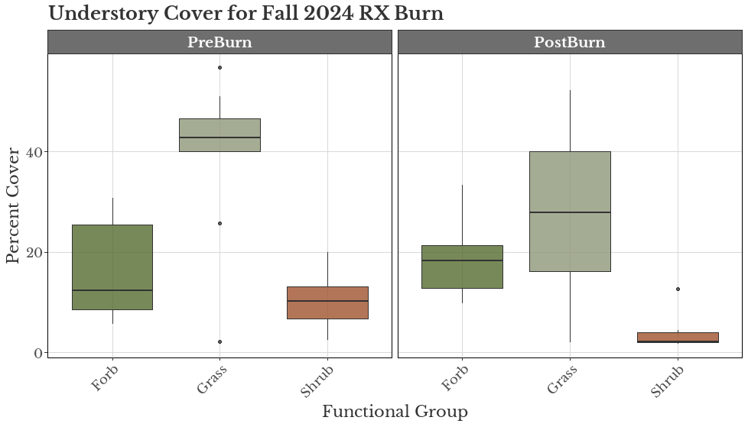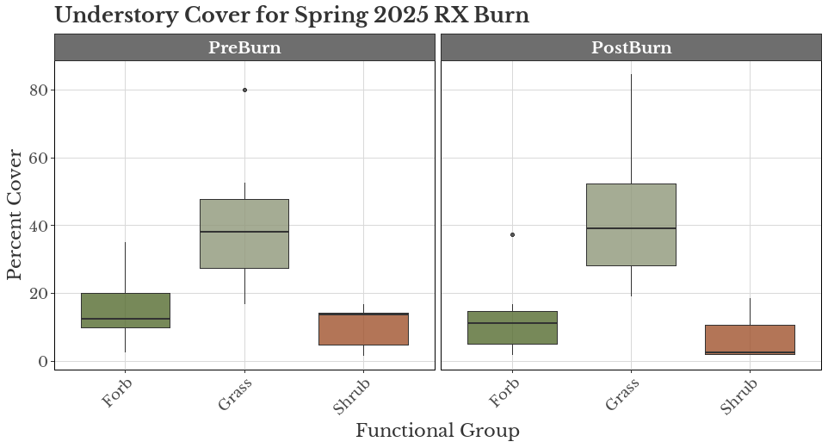
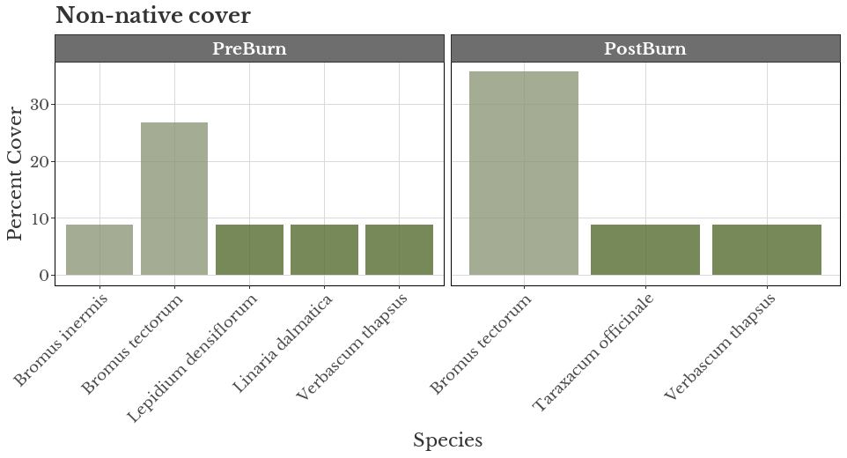
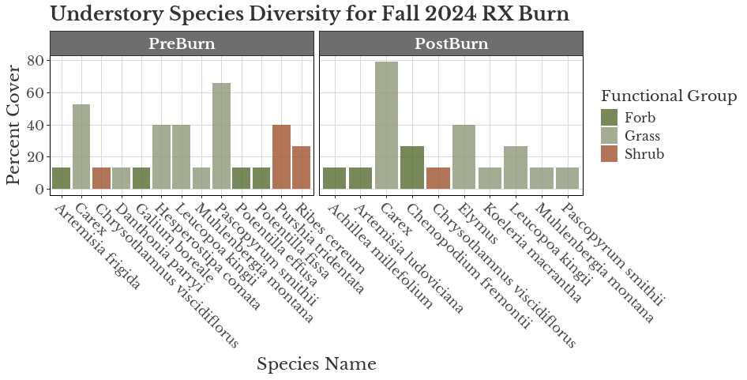
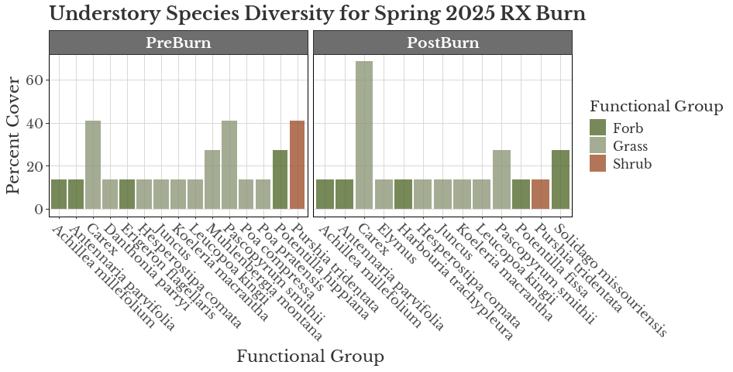

PERMANOVA for functional groups:
- Fall24: p = .323
- Spring25: p = .509
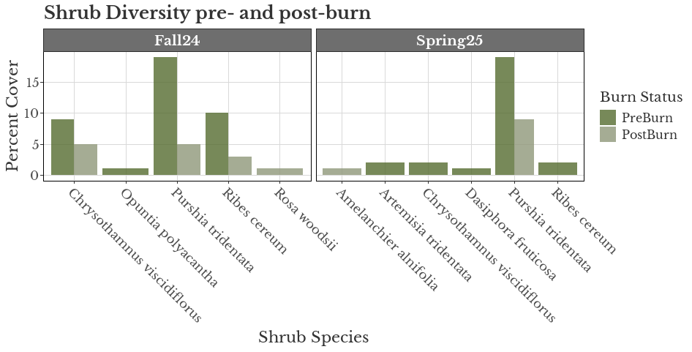
PERMANOVA for shrub diversity: Fall24 – p = 0.626, Spring25 – p = 0.406

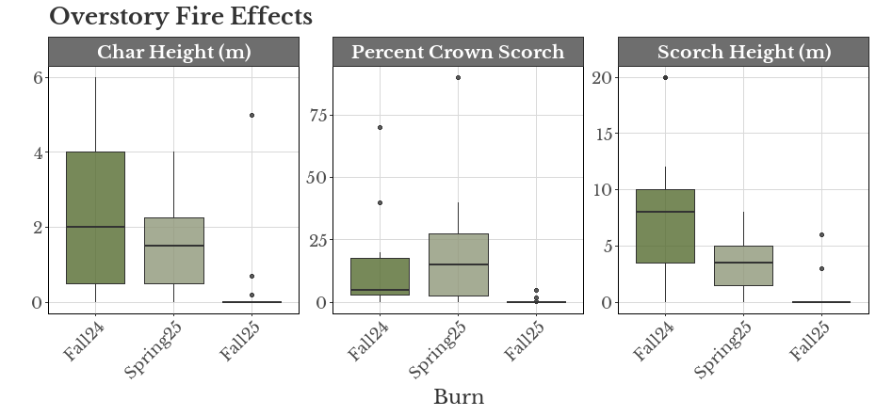
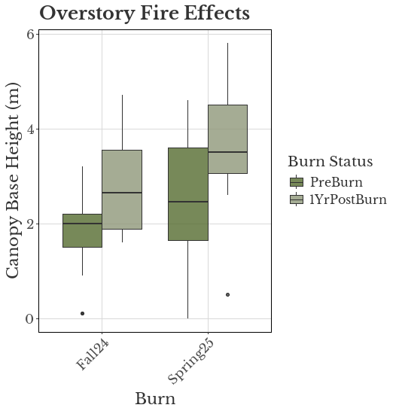
CBH paired wilcox test: fall24 – p < 0.05, spring25: p < 0.05

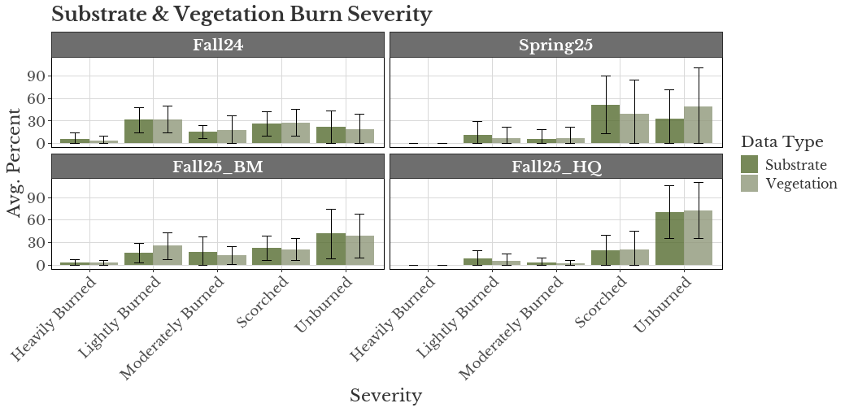

Pipo27 | Conifer forest, some cut stumps, needle litter | Tl1
Pipo09 | Conifer forest, slightly more open.shrubby than pipo27 | Tl1
Pips05 | Open pine savannah, sagebrush | Gs2
Pips02 | Very open, large snag, sagebrush, lots of bare soil/litter | SH1/SH2
Pips01 | Grass > shrub. But still has shrubs. Very open pine savannah | Gs1
Pips14 | More continuous grass, 1 tree, still shrubs | Gr1or gs1
Pips16 | Conifer forest, sagebrush | Tu1
Pips08 | Rocky, open, shrubby | Sh1
Rap16 | No trees, grassy | Gr2
Rap15 | Conifer forest | Tl1
Rap14 | Grassy, open | Gr1
Rap13 | Conifer forest | Tu1
Rap10 | Open/rocky pine savannah; shrubby and grassy | Gs2
Rap09 | Similar to rap10 | Gs2
Rap06 | Conifer forest but on the edge; also grassy but not really shrubby | Tu1
Rap04 | Grassy forest, not many shrubs | Gr2 or GS1
Rap03 | Grassy/ very open pine savannah. Some shrub but also continuous grass | Gs2
Rap02 | Open shrub/grass. Grass is continuous between shrubs | Gs2
Rap01 | Conifer forest but discountinuous understory; mostly grass and sparse shrubs. Kind of rocky | Tu1

 | 1hr | 10hr | 100hr
GR1 | .1 | 0 | 0
GR2 | .1 | 0 | 0
SH1 | .25 | .25 | 0
SH2 | 1.35 | 2.4 | .75
GS1 | .2 | 0 | 0
GS2 | .5 | .5 | 0
TU1 | .2 | .9 | 1.5
TL1 | 1 | 2.2 | 3.6
TL3 | .5 | 2.2 | 2.8
TU4 | 4.0 | 0 | 0
TU5 | 4 | 4 | 3

*talk to nate/nate about IFTDSS results

